Aws amazon connect

* **AWS Connect is an open platform by Amazon which helps organizations to set up easy customer service for their clients. Organizations can swiftly set up a contact center, add personnel from anywhere, and start communicating with clients.**

**Table of Contents:**

* **AWS Connect Benefits**
* **AWS Connect Features**
* **How does AWS Connect work?**
* **AWS Connect Use Cases**
* **How to Set Up AWS Connect?**
* **Pricing**
* **Conclusion**

# Aws connect benefits

## 1.Cost Effective

* When compared with traditional contact center system, Amazon contact is significantly less expensive, and you can save upto 80% your money.
* You are billed only for the services you use at no extra cost.
* Also there are no long-term contracts, no minimum monthly fees, and zero upfront licensing fees.
* The pricing is not based on agent seats, maintenance, or peak capacity.

## 2. Scalable

* Amazon connect gives you freedom of scaling your center in case you want to expand your business and hire more agents.
* Customer can access connect from anywhere in the world.

## 3. Easy to use

* Amazon connect is pretty easy to use in a few clicks you set up an omnichannel contact center and agent start contacting customers through or massages.

# Aws connect features

There are six features

1. Automated call

* Amazon Connect offers a call automation feature, which can be very beneficial when a reminder or alert call is to be made. For eg, credit card fraud warnings, or reminders like booking a flight. This gives users a trustworthy and excellent service experience.

1. Audio features

* Good audio quality is a big factor as no one would to hear a bad voice from your end. With amazon connect you get 16kHz high-quality audio support and a call recording facility.

1. Real time analytics

* Amazon Connect frees you of the burden of manually recording each conversation’s detail and making a report. You are provided with a real-time dashboard and historical metrics. You can use that data for finding the latest trends, this will eventually help in improving your performance.

1. Omnipresent channel

* Amazon Connect offers the same UI for voice and chats interaction, even if the call center agents are not technically efficient they can easily understand the platform.
* Having an Omnipresent channel is the biggest advantage it offers, it eliminates the need of building different workflows for chat and voice channels individually. Amazon Connect allows you to make rules and call flies and use them across the channels.

1. Chatbots

* Amazon Connect creates natural chatbot experiences via contact flows, routing, analytics, and voice interaction.
* Additionally, brands can add Amazon Lex. The speech recognition and natural language processing technologies utilized by Alexa are also used by this service.
* Before every client request is routed to an agent, functionality to handle early encounters or answer typical inquiries is provided.
* As a result, creating an Aws chatbot is simple, quick, and requires no coding. Moreover, every discussion is safely encrypted.

1. Fraud detection

* In a few click, you can make fraud detection model. A machine learning model that automatically identifies if the caller is trying to extract any unauthorized data.

# How does Aws Connect work?

AWS Connect, commonly referred to as Amazon Connect, is a call center and cloud telephony service provided by Amazon web services.

Companies build call processes, rent phone lines, and establish users on their own Amazon Connect instance.

When clients call the phone numbers, Amazon Connect call flow routes the call to the appropriate group, chooses an agent from the pool of candidates, and transfers the call to her desktop computer, mobile phone, or tablet. It is also possible to report and record all activity.

## AWS Connect Use Cases

* **Automation of paths:**  After analyzing the data you can create a contact flow that automates the process of responding to user queries. This way you can save both resources and time.

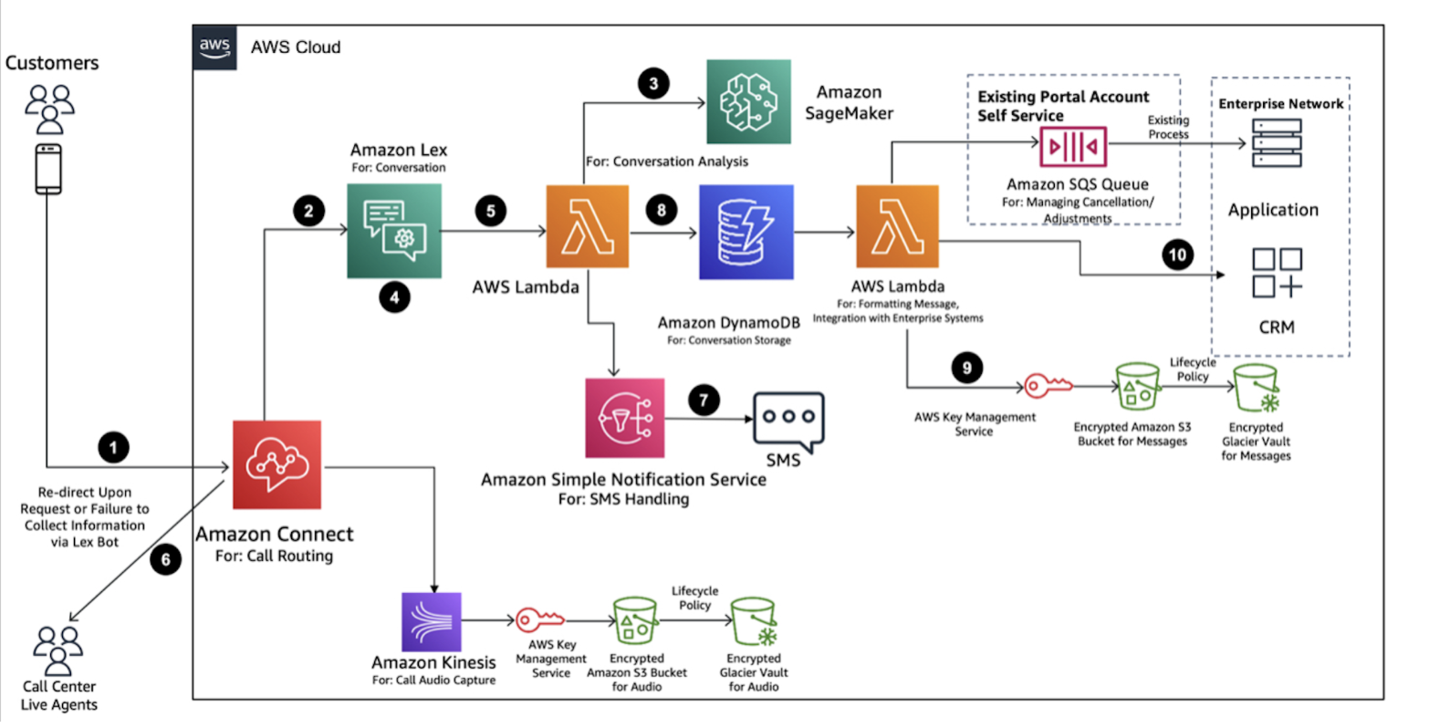

* **Personalised solutions:** With lambda functions integration, customers can be provided with a more personalized experience using AI. Customers can further be directed to appropriate queues by analyzing their data, this will thus provide them with a more familiar experience.
* **Managing peaks:** AWS connect is highly scaleable and comes with Artificial Intelligence, by integrating them you can provide an excellent experience to your customers.

## **How to Set Up AWS Connect?**

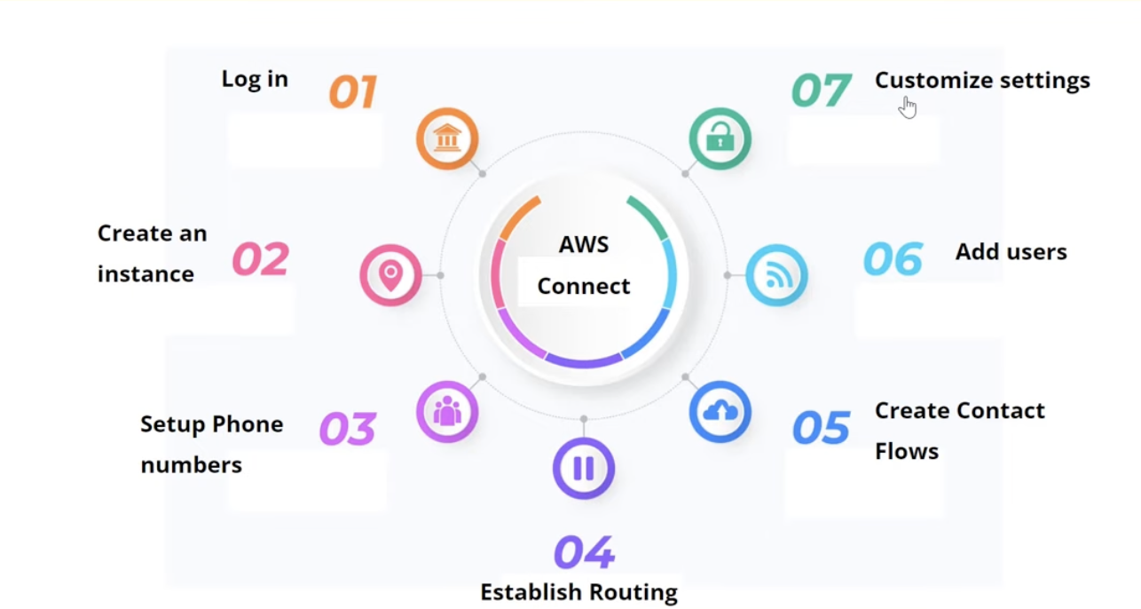

**Setting up AWS Connect is a pretty easy task, simply follow the steps mentioned below:**

1. **Log In** – Log in to the Amazon Connect Console from your account.
2. **Create an Instance** – All information related to the contact center will be stored here.
3. **Set up phone numbers** – You are required to claim a phone number for voice-supported centers. You can either use your own number or AWS will provide you with one.
4. **Establish routing** – Find the appropriate operation queues. Indicate whether agents must use voice, chat, or task when creating routing profiles.
5. **Create contact flows** – These will establish the entire customer experience journey from beginning to end. Keep in mind that one contact flow can be used for tasks, voice, and chat.
6. **Add users** – Here, you can set up the agents’ and managers’ profiles and allot them a routing/security profile.

## Pricing

Companies that use Amazon Connect only pay for the usage they require. After the first minute, Amazon Connect Voice, for example, charges a per-second fee.

**Here is a list of pricing figures for Amazon Connect by feature:**

* **Voice –** $0.018 per minute
* **Chat –** $0.004 per minute
* **Tasks –** $0.04 per task
* **Customer Profiles –** $0.0025 per profile/per month
* **Voice ID –** $0.025 per deal

Amazon Connect doesn’t charge any monthly fee or any up-front payment.

## 

## **Conclusion**

Amazon Connect provides an efficient low-cost solution in situations when companies might require the hiring of new agents temporarily, and in such situations, a little mismanagement can lead to a very negative impact on customer satisfaction. AWS Connect offers easy to use interface with no coding required to operate, this makes it really convenient for even non-technical agents to operate it.

Thank you